Task 1:

siddh@DESKTOP-U9A0S88 MINGW64 ~/OneDrive/Desktop/GitTryClass (master)
$ git config --global user.name "Siddharth Shah"

siddh@DESKTOP-U9A0S88 MINGW64 ~/OneDrive/Desktop/GitTryClass (master)
$ git config --global user.email "siddharthshah087@gmail.com"

siddh@DESKTOP-U9A0S88 MINGW64 ~/OneDrive/Desktop/GitTryClass (master)
$ git config --global –list

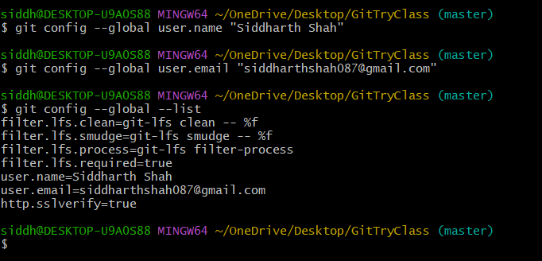

Task 2:

siddh@DESKTOP-U9A0S88 MINGW64 ~/OneDrive/Desktop/git-hands-on
$ git init

siddh@DESKTOP-U9A0S88 MINGW64 ~/OneDrive/Desktop/git-hands-on (master)
$ git status

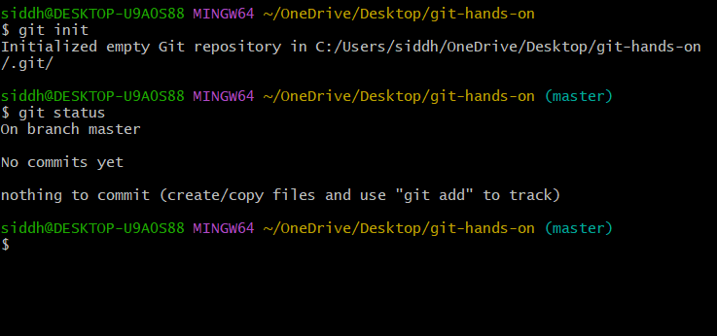

Task 3:

siddh@DESKTOP-U9A0S88 MINGW64 ~/OneDrive/Desktop/git-hands-on (master)
$ git status

siddh@DESKTOP-U9A0S88 MINGW64 ~/OneDrive/Desktop/git-hands-on (master)
$ git add -A

siddh@DESKTOP-U9A0S88 MINGW64 ~/OneDrive/Desktop/git-hands-on (master)
$ git commit -m "This is Description of project"

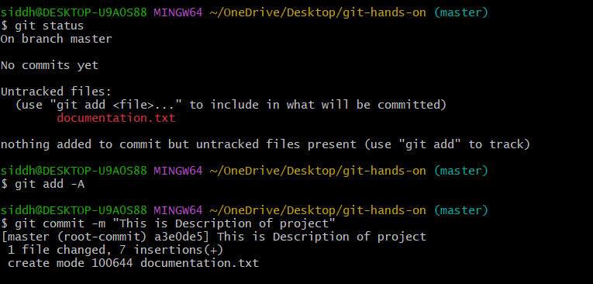

Task 4:

siddh@DESKTOP-U9A0S88 MINGW64 ~/OneDrive/Desktop/git-hands-on (master)
$ git status

siddh@DESKTOP-U9A0S88 MINGW64 ~/OneDrive/Desktop/git-hands-on (master)
$ git diff

siddh@DESKTOP-U9A0S88 MINGW64 ~/OneDrive/Desktop/git-hands-on (master)
$ git add -A

siddh@DESKTOP-U9A0S88 MINGW64 ~/OneDrive/Desktop/git-hands-on (master)
$ git commit -m “This file`s changes are saved”
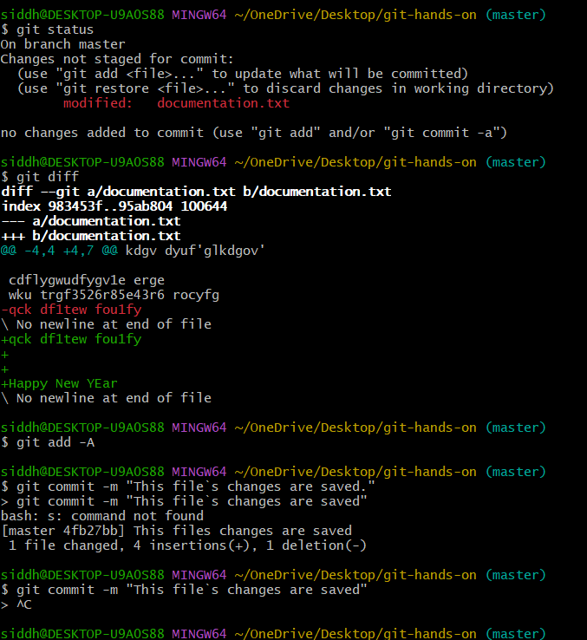

Task 5:

siddh@DESKTOP-U9A0S88 MINGW64 ~/OneDrive/Desktop/git-hands-on (master)
$ git log

siddh@DESKTOP-U9A0S88 MINGW64 ~/OneDrive/Desktop/git-hands-on (master)
$ git log --pretty=oneline

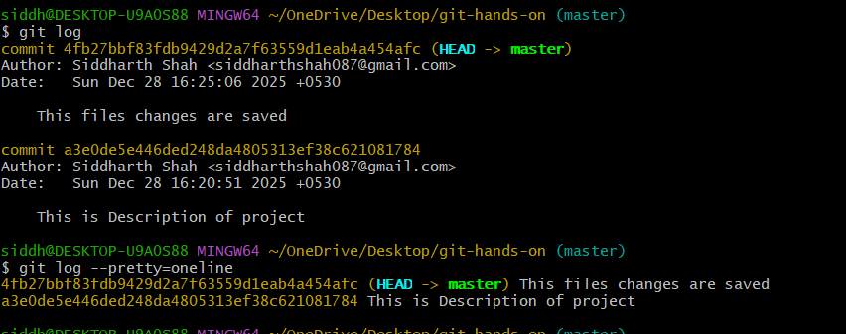

Task 6:

siddh@DESKTOP-U9A0S88 MINGW64 ~/OneDrive/Desktop/git-hands-on (master)
$ git checkout -b feature-1

siddh@DESKTOP-U9A0S88 MINGW64 ~/OneDrive/Desktop/git-hands-on (feature-1)
$ git status

siddh@DESKTOP-U9A0S88 MINGW64 ~/OneDrive/Desktop/git-hands-on (feature-1)
$ git add -A

siddh@DESKTOP-U9A0S88 MINGW64 ~/OneDrive/Desktop/git-hands-on (feature-1)
$ git commit -m "Features are added and commited in feature-1 branch"

siddh@DESKTOP-U9A0S88 MINGW64 ~/OneDrive/Desktop/git-hands-on (feature-1)
$ git status

siddh@DESKTOP-U9A0S88 MINGW64 ~/OneDrive/Desktop/git-hands-on (feature-1)
$ git checkout main

siddh@DESKTOP-U9A0S88 MINGW64 ~/OneDrive/Desktop/git-hands-on (feature-1)
$ git checkout master
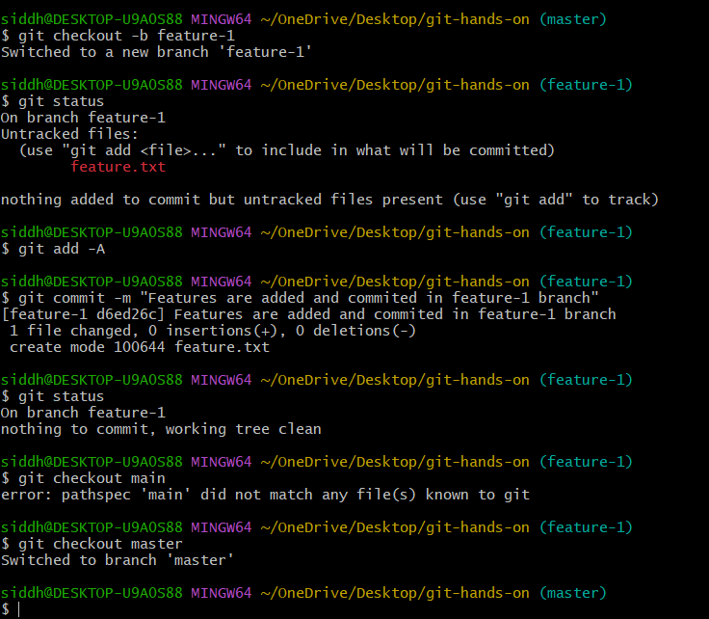

Task 7:

siddh@DESKTOP-U9A0S88 MINGW64 ~/OneDrive/Desktop/git-hands-on (master)
$ git merge feature-1

siddh@DESKTOP-U9A0S88 MINGW64 ~/OneDrive/Desktop/git-hands-on (master)
$ git log

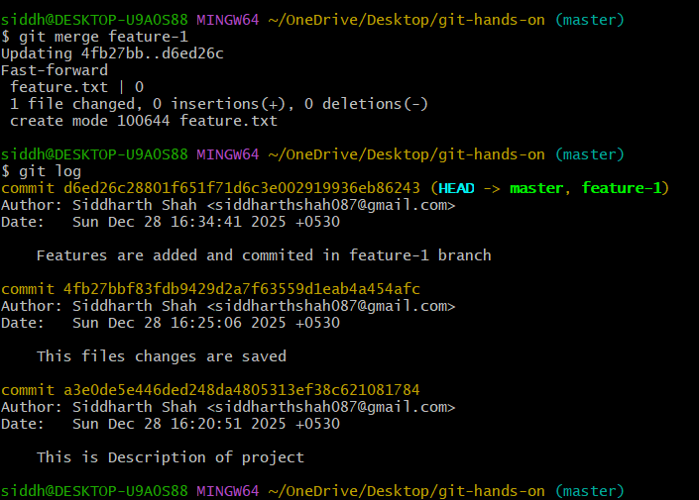

Task 8:

siddh@DESKTOP-U9A0S88 MINGW64 ~/OneDrive/Desktop/git-hands-on (master)
$ git remote add origin https://github.com/Siddharth0809/GitTaskCdac.git

siddh@DESKTOP-U9A0S88 MINGW64 ~/OneDrive/Desktop/git-hands-on (master)
$ git remote -v
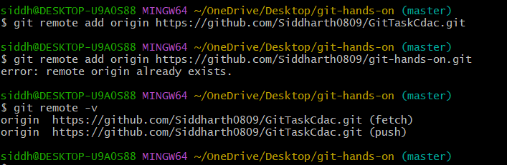

Task 9:
siddh@DESKTOP-U9A0S88 MINGW64 ~/OneDrive/Desktop/git-hands-on (master)
$ git push -u origin master
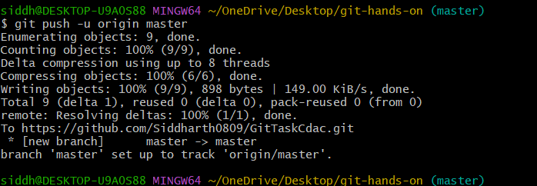

Task 10:
siddh@DESKTOP-U9A0S88 MINGW64 ~/OneDrive/Desktop/git-hands-clone
$ git init

siddh@DESKTOP-U9A0S88 MINGW64 ~/OneDrive/Desktop/git-hands-clone (master)
$ git clone https://github.com/Siddharth0809/GitTaskCdac.git

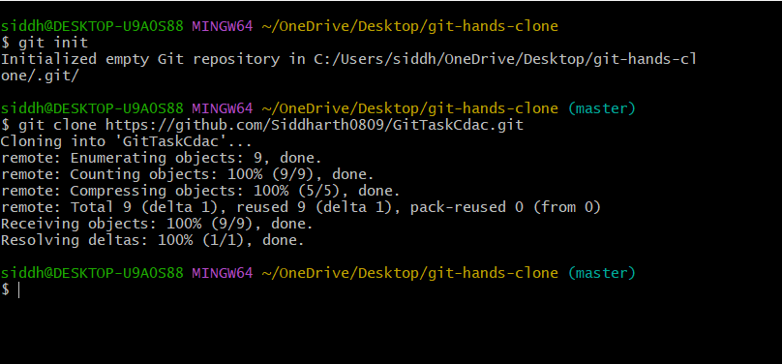

Task 11:
siddh@DESKTOP-U9A0S88 MINGW64 ~/OneDrive/Desktop/git-hands-on (master)
$ git clone https://github.com/Siddharth0809/GitTaskCdac.git

siddh@DESKTOP-U9A0S88 MINGW64 ~/OneDrive/Desktop/git-hands-on (master)
$ git checkout --documentation.txt
siddh@DESKTOP-U9A0S88 MINGW64 ~/OneDrive/Desktop/git-hands-on (master)
$ git status
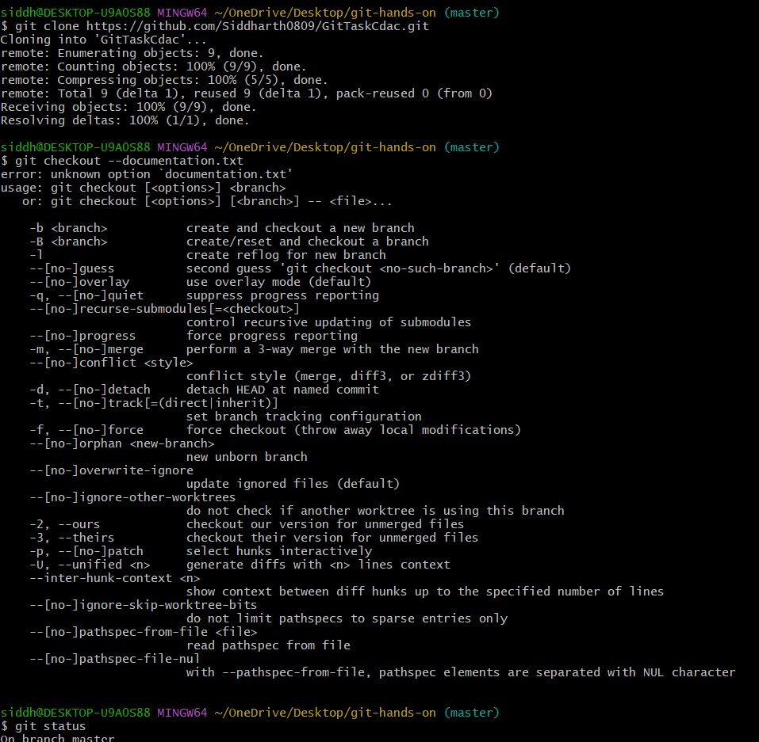

Task 12:
siddh@DESKTOP-U9A0S88 MINGW64 ~/OneDrive/Desktop/git-hands-on (master)
$ git rm feature.txt

siddh@DESKTOP-U9A0S88 MINGW64 ~/OneDrive/Desktop/git-hands-on (master)
$ git commit -m "feature.txt file is finally deleted"
